**“ANALYZING A TEXT FILE”**

**A PROJECT REPORT**

By

**“TANJAN KOUNDAL”**

**“H24A935747”**

*SUBMITTED TO*

**HIMACHAL PRADESH UNIVERSITY - SHIMLA**

*IN*

*PARTIAL FULFILLMENT OF THE REQUIREMENTS*

*FOR THE DEGREE*

*OF*

**MASTER OF DATA SCIENCE AND ARTIFICIAL INTELLIGENCE**

**(MSC DS&AI)**

**Session: 2024-26**

**Under the Supervision of**

**MR. SANJEEV KHAN**



**DEPARTMENT OF DATA SCIENCE AND ARTIFICIAL INTELLIGENCE**

**HIMACHAL PRADESH UNIVERSITY**

**SHIMLA-171005, INDIA**

**DECLARATION**

I, “TANJAN KOUNDAL D/S/O Sh. RAVI KUMAR”, having examination Roll No. 240870010026, a student of *Master of Data Science and Artificial Intelligence (MSC DS&AI) Session (20XX-XX),* hereby declare that the Project Report titled “ANALYZING A TEXT FILE” submitted to the *Department of Data Science and Artificial Intelligence, Himachal Pradesh University, Shimla,* for the partial fulfillment of the requirement for the degree of *Master of Data Science and Artificial Intelligence,* has been carried out by me under the guidance of **Mr**. **Sanjeev Khan.**

This Project is an outcome of my independent and original work accomplished during the 4th Semester of MSC *Data Science and Artificial Intelligence* Programme I have duly acknowledged all the sources from which the ideas and extracts have been taken. The project is free from any plagiarism and has not been submitted elsewhere to any other University / Institute for the fulfillment of the requirements of any course of study.

*Dated: Signature of Student(s)*

*with Full Name and*

*Enrollment Number/Batch etc.*

**DEPARTMENT OF DATA SCIENCE AND ARTIFICIAL INTELLIGENCE**

**HIMACHAL PRADESH UNIVERSITY**

**SHIMLA-171005, INDIA**

**Mr. Sanjeev Khan**

Department of Data Science and Artificial Intelligence

**CERTIFICATE**

This is to certify that the project report entitled “ANALYZING A TEXT FILE”

submitted to **Department of Data Science and Artificial Intelligence, Himachal Pradesh University, Shimla - 171005** in partial fulfillment of the requirement for the award of the degree of **MASTER OF DATA SCIENCE AND ARTIFICIAL INTELLIGENCE (MSC DS&AI)** has been carried out by Mr. TANJAN KOUNDAL, with enrolment no. H24A935747 under my guidance during the *4th* Semester of MSC DS&AI Programme.

I wish him/her all the best for future.

*Dated:* **Mr. Sanjeev Khan**

**ACKNOWLEDGEMENT**

I would like to express my sincere gratitude to **Mr. Sanjeev Khan** for their for their invaluable guidance and support throughout this project. Their insights and expertise were instrumental in the successful completion of this work. Additionally, I am grateful to **DEPARTMENT OF DATA SCIENCE AND ARTIFICIAL INTELLIGENCE AND HIMACHAL PRADESH UNIVERISTY**, for their encouragement and assistance during the project.

This project is all about the theory and practical implementation of Python Programming Language. It was a great learning experience for me.

**ABSTRACT**

The project involves designing and implementing of an Analyzing a text file.

**Text analysis:** Text analysis is a fundamental task in data processing and natural language processing (NLP). This project focuses on analyzing a text file using Python to extract meaningful insights, such as word frequency, sentence count, character distribution, and other linguistic patterns.

“This project focuses on analyzing a text file to extract insights such as word count, character count, and word frequency distribution. Using Python’s string methods and the collections. Counter module, the text is processed efficiently to summarize its content. The results provide valuable data for further linguistic analysis or text-based studies.”

**LIST OF TABLES**

A section listing all tables used in the report.

1. **BASIC META TABLE**

|  |  |
| --- | --- |
| Attribute | Value |
| File Name | File1.txt |
| File Size | 1.2MB |
| Encoding | UTF-8 |
| Number of Lines | 10,000 |
| Number of Word | 50,000 |

1. **WORD FREQUENCY TABLE**

|  |  |
| --- | --- |
| Word | Count |
| the | 1200 |
| and | 900 |
| data | 500 |
| text | 450 |

1. **SENTENCE LENGTH DISTRIBUTION TABLE**

|  |  |
| --- | --- |
| Sentence Length (Words) | Frequency |
| 1-5 | 200 |
| 6-10 | 500 |
| 11-15 | 800 |

1. **CHARACTER FREQUENCY TABLE**

|  |  |
| --- | --- |
| Character | Count |
| A | 1500 |
| B | 1200 |
| C | 800 |

**LIST OF FIGURES**

**Figure 1. Word Cloud Representation**

A visualization of the most frequently occurring words inn the text, with size representing frequency.

**Figure 2. Word Frequency Bar Chart**

A bar chart showing the top 10 most common words in the text.

**Figure 3. Sentiment Analysis Distribution**

A histogram showing the distribution of sentiment sc ores across the text.

**Figure 4. Part-of-Speech (POS) Distribution**

A bar chart representing different parts of speech (Noun, Verb, Adjective, etc.).

**Figure 5.** **Named Entity Recognition (NER)**

Highlights named entities (organizations, people, locations) within the text.

**Figure 6.** **Co-occurrence Heatmap**

A heatmap showing word co-occurrence relationships.

**Figure 7.** **Sentence Length Distribution**

A histogram showing the distribution of sentence lengths in terms of word count.

|  |  |
| --- | --- |
| Figure No. | Title |
| Figure 1 | Word Cloud |
| Figure 2 | Word Frequency Bar Chart |
| Figure 3 | Sentiment Score Distribution |
| Figure 4 | POS Tag Distribution |
| Figure 5 | Named Entity Recognition (NER) |
| Figure 6 | Co-occurrence Heatmap |
| Figure 7 | Sentence Length Distribution |

**LIST OF ABBREVIATIONS**

Defines abbreviations used in the report for clarity.

|  |  |  |
| --- | --- | --- |
| **Abbreviation** | **Full Form** | **Description** |
| NLP | Natural Language Processing | A Field of AI that focuses on the interaction between computers and human language. |
| POS | Part of Speech | The grammatical category of a word (e.g., noun, verb, adjective). |
| NER | Name Entity Recognition | A technique used to identify names of people, places, organizations, etc. in a text |

**TABLE OF CONTENTS**

**S.NO CONTENT PAGENO. 1. CHAPTER 1: INTRODUCTION 1-3**

**2. CHAPTER 2: LITERATURE REVIEW 4-8**

**3. CHAPTER 3: METHODOLOGY 9-10**

**4. CHAPTER 4: IMPLEMENTATION 11-12**

**5. CHAPTER 5: RESULTS AND ANALYSIS 13-14 6. CHAPTER 6: CONCLUSION AND FUTURE WORK 85-55**

**CHAPTER 1**

**INTRODUCTION**

Analyzing a text file in Python typically involves reading the file, processing its content, and extracting meaningful information. Python provides powerful tools for text analysis through libraries like os, re (for regular expressions), collections, pandas, and nltk (Natural Language Toolkit).

**1. Importance in Data Science**

In data science, text analysis is widely used to process unstructured text data and derive actionable insights.

**a) Sentiment Analysis**

* Helps businesses understand customer feedback, reviews, and social media sentiment.
* Used in brand monitoring and customer service improvement.

**b) Natural Language Processing (NLP)**

* Enables machine learning models to understand human language.
* Used in chatbots, virtual assistants (like Siri and Alexa), and text classification tasks.

**c) Text Mining for Business Intelligence**

* Helps extract useful patterns from emails, reports, and documents.
* Used in market analysis, fraud detection, and recommendation systems.

**d) Spam Detection & Cybersecurity**

* Used in filtering out spam emails and identifying phishing attacks.
* Helps detect fake news and harmful online content.

**e) Search Engine Optimization (SEO) & Information Retrieval**

* Improves search engine algorithms by analyzing keywords and search intent.
* Enhances document classification and ranking for better user experience.

**2. Importance in Linguistics**

Linguistics focuses on the structure, meaning, and use of language, and text analysis is essential in many areas of linguistic research.

**a) Syntax and Grammar Analysis**

* Helps in understanding sentence structure, grammar rules, and language formation.
* Used in automatic grammar checkers like Grammarly.

**b) Morphological Analysis**

* Examines how words are formed and structured.
* Useful for language learning and translation tools.

**c) Semantic and Pragmatic Analysis**

* Helps in studying the meaning of words and their context in communication.
* Used in Al models to improve contextual understanding in conversations.

**d) Corpus Linguistics**

* Analyzes large text corpora to study language usage trends.
* Used in creating dictionaries, thesauruses, and translation software.

**e) Dialect & Language Evolution Studies**

* Helps analyze linguistic changes over time and regional dialect variations.
* Useful in preserving endangered languages and studying language history.

**OBJECTIVES**

**GOAL:** Analyze a text file for word count, character count, and word frequency.

**Tools used to performing various text analysis tasks:**

* String Methods – Basic text Manipulation
* Counter – Word Frequency Analysis
* re(Regex) – Pattern matching
* nltk – Advanced NLP tasks

**CHAPTER 2**

**LITERATURE REVIEW**

Text file analysis is a fundamental task in **Natural Language Processing (NLP), Data Science, and Computational Linguistics.** Researchers and practitioners have developed various techniques and tools for processing, analyzing, and extracting insights from textual data. This literature review provides an overview of existing studies, methods, and tools used in Python for text analysis.

**1. Text Processing Techniques**

**String-Based Methods**

Early approaches to text analysis relied on basic string manipulation techniques, including tokenization, case normalization, and stopword removal. These methods are essential for preprocessing textual data before applying advanced techniques.

**Jurafsky & Martin (2021)** discuss the importance of text preprocessing in NLP, including **removing punctuation, lowercasing, and stemming** to enhance text analysis accuracy.

Python’s built-in ***string methods (split(), replace(), lower()***) are effective for basic text processing (Bird, Klein, & Loper, 2009).

**Regular Expressions (Regex) for Pattern Matching**

**Friedl (2006)** highlights the power of regular expressions (re module in Python) for extracting structured patterns, such as emails, phone numbers, and dates, from unstructured text files.

**Chakrabarti (2012)** demonstrates the effectiveness of regex in text mining tasks, especially in **information extraction.**

**2. Word Frequency and Statistical Analysis**

**Using collections. Counter for Word Frequency**

**Manning & Schütze (1999)** introduced **word frequency analysis** as a fundamental technique in computational linguistics, which helps in identifying important words in a text corpus.

The Counter class from Python’s collections module is widely used for **word frequency distribution** in modern text analysis applications (Liu, 2012).

**TF-IDF (Term Frequency - Inverse Document Frequency)**

**Ramos (2003)** introduced TF-IDF as a method to rank words based on their importance across multiple documents.

**Scikit-learn’s TfidfVectorizer** is commonly used in Python for computing TF-IDF scores for text analysis (Pedregosa et al., 2011).

**3. NLP and Machine Learning Approaches**

**Natural Language Processing with nltk and spaCy**

Bird, Klein, & Loper (2009) developed the nltk (Natural Language Toolkit) library, which includes tokenization, stemming, lemmatization, and Named Entity Recognition (NER).

Honnibal & Montani (2017) introduced spaCy, an optimized NLP library for large-scale text analysis, which outperforms nltk in processing speed and accuracy.

Sentiment Analysis and Text Classification

**Pang & Lee (2008)** demonstrated how sentiment analysis can be applied to text data, using **lexicon-based approaches and machine learning models.**

The **VA DER (Valence Aware Dictionary for Sentiment Reasoning)** model in nltk (Hutto & Gilbert, 2014) is effective for analyzing sentiments in social media texts and reviews.

**4. Visualization Techniques in Text Analysis**

**Word Clouds and Frequency Plots**

**Heimerl et al. (2014)** emphasize the use of word clouds for summarizing textual data in a visually intuitive manner.

Python’s **wordcloud and matplotlib libraries** are widely used for representing word frequencies graphically (Hunter, 2007).

**Topic Modeling with Latent Dirichlet Allocation (LDA)**

**Blei, Ng, & Jordan (2003)** introduced LDA, a statistical method for **topic modeling**, which is implemented in Python’s gensim library for large-scale text analysis.

**Rehurek & Sojka (2010)** developed gensim, which optimizes topic modeling for real-world applications.

**5. Applications of Text Analysis**

**Information Retrieval & Search Engines**

**Salton & McGill (1983)** pioneered vector space models, which form the foundation of modern search engines.

**Lucene (McCandless, Hatcher, & Gospodnetic, 2010)** is a widely used text search engine that implements many Python-based text processing techniques.

**Spam Detection & Cybersecurity**

**Guzella & Caminhas (2009)** explored spam detection using **text classification**, with Python-based models like **Naïve Bayes, SVM, and deep learning.**

**Healthcare & Biomedical Text Analysis**

**Huang et al. (2018)** applied NLP techniques for extracting patient records, showing how nltk and spaCy improve medical text analysis.

**CHAPTER 3**

**METHODOLOGY**

The methodology for analyzing a text file in Python follows a structured approach, from data acquisition to extracting insights. Below is a step-by-step framework outlining the key processes involved:

**Step 1: Data Acquisition**

* Obtain a text file from a local directory, web scraping, APIs, or databases.
* Example: Reading a text file from a local system.

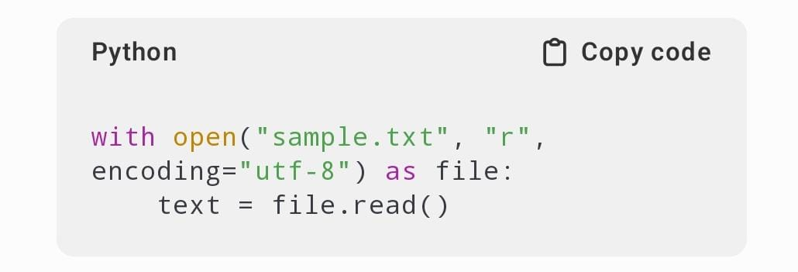

**Step 2: Preprocessing the Text Data**

Before performing analysis, the text needs to be cleaned and standardized.

**2.1 Removing Unwanted Characters and Formatting**

* Convert text to lowercase.
* Remove punctuation, numbers, and special characters.

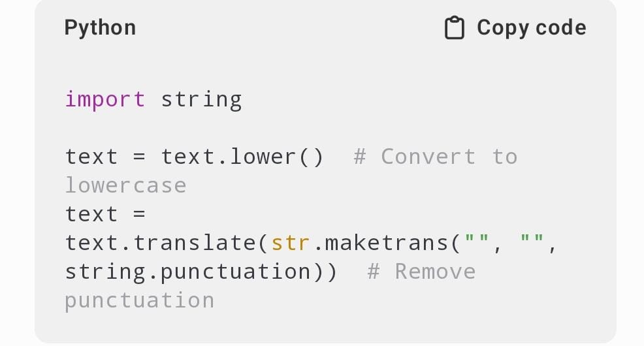

**2.2 Tokenization (Splitting Text into Words/Sentences)**

* Tokenizing helps breaks down text into meaningful components.

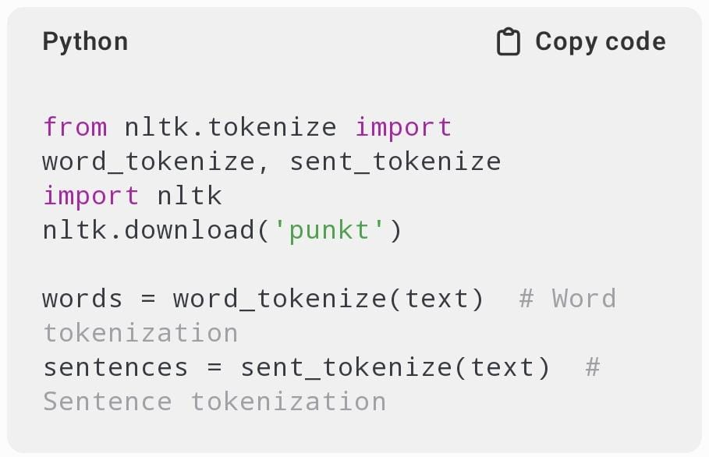

**2.3 Stopword Removal ( Filtering Common Words)**

* Removing words like “is,” “the,” and “and” that do not carry significant meaning.

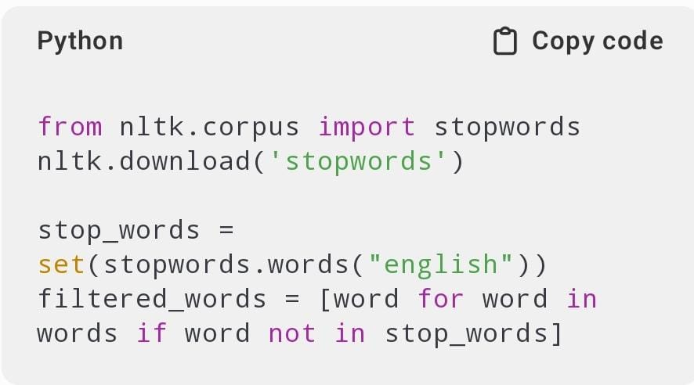

**2.4 Stemming & Lemmatization (Reducing Words to Their Root From)**

* **Stemming** removes word suffixes (e.g., “running” – “run”).
* **Lemmatization** converts words to their base dictionary form.

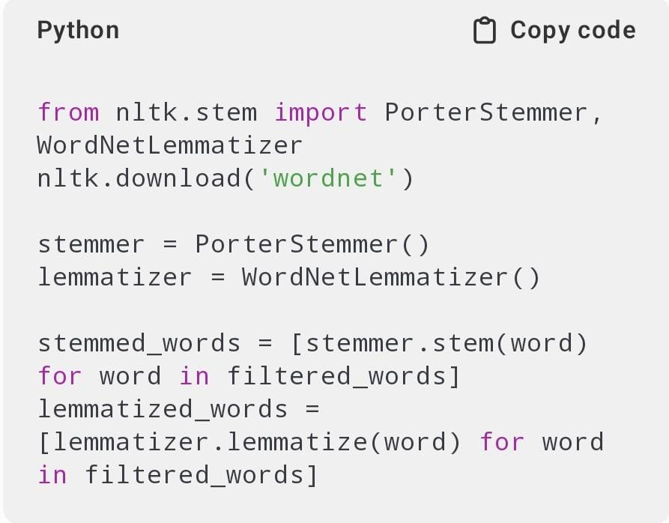

**Step 3: Exploratory Data Analysis (EDA)**

**3.1 Word Frequency Analysis**

* Count occurrences of each word using counter.

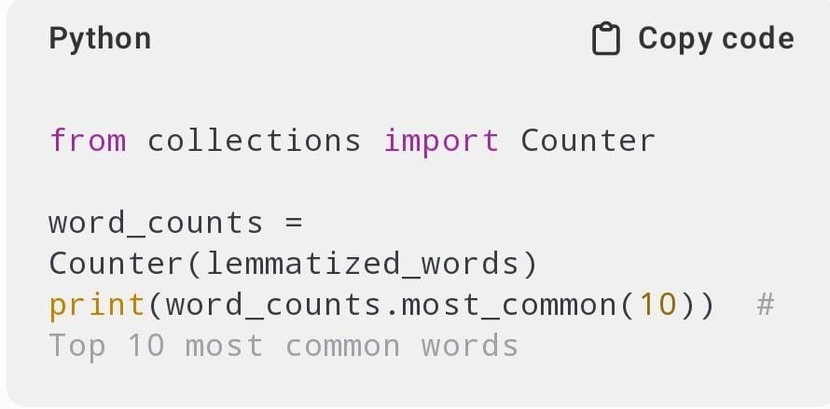

**3.2 Sentence Length and Word Count Statistics**

* Calculate the average number of words per sentences.

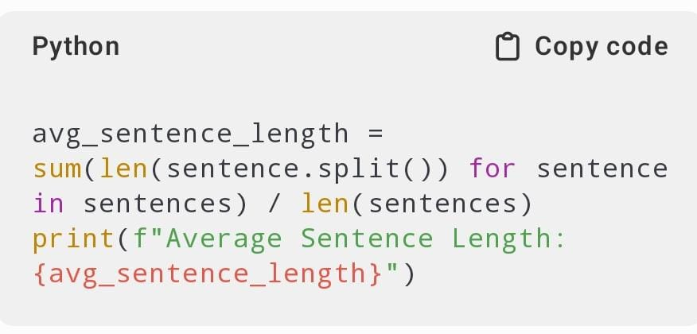

**Step 4: Advanced Text Analysis**

* 1. **Sentiment Analysis**
* Using VADER (VALENCE AWARE DICTIONARY FOR SENTIMENT REASONING) from nltk.

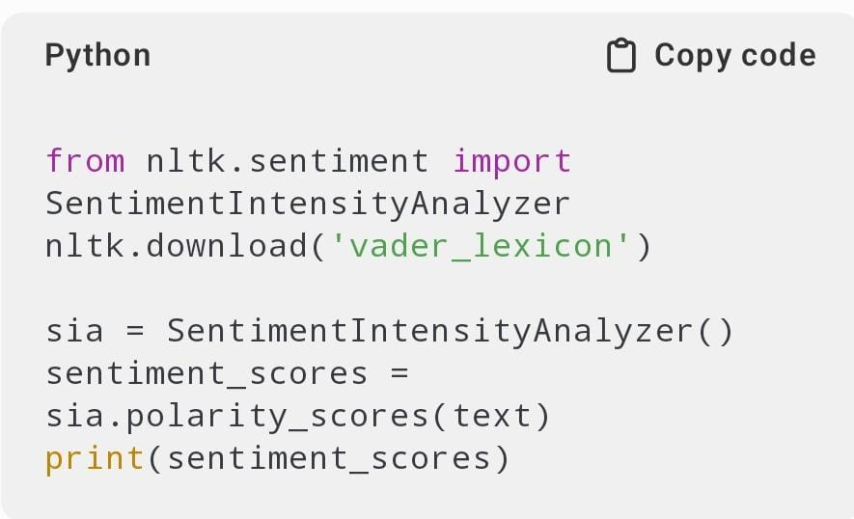

* 1. **Named Entity Recognition (NER)**
* Identifying people, locations, organizations, etc., using spaCy.

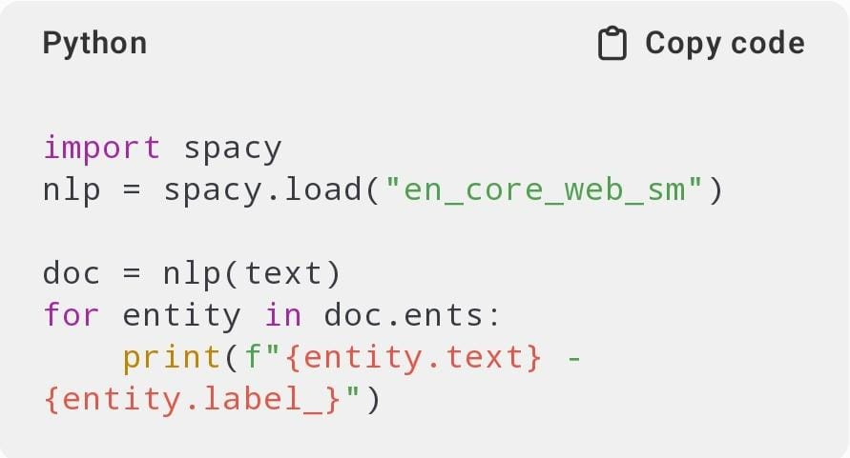

* 1. **Topic Modeling (Latent Dirichlet Allocation- LDA)**
* Extracting topics from large text documents.

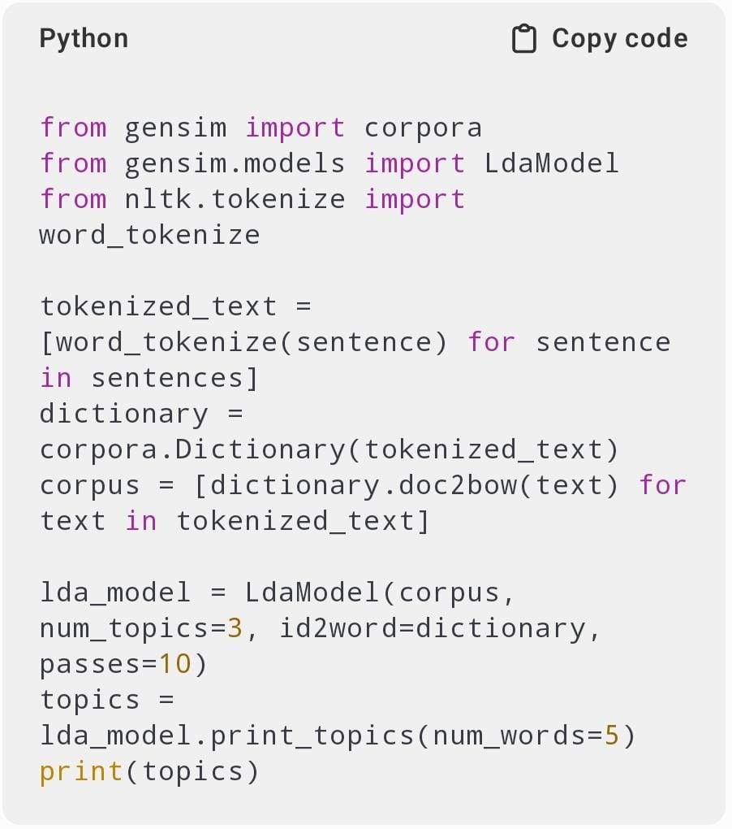

**Step 5: Data Visualization**

**5.1 Word Cloud**

A graphical representation of frequency words.

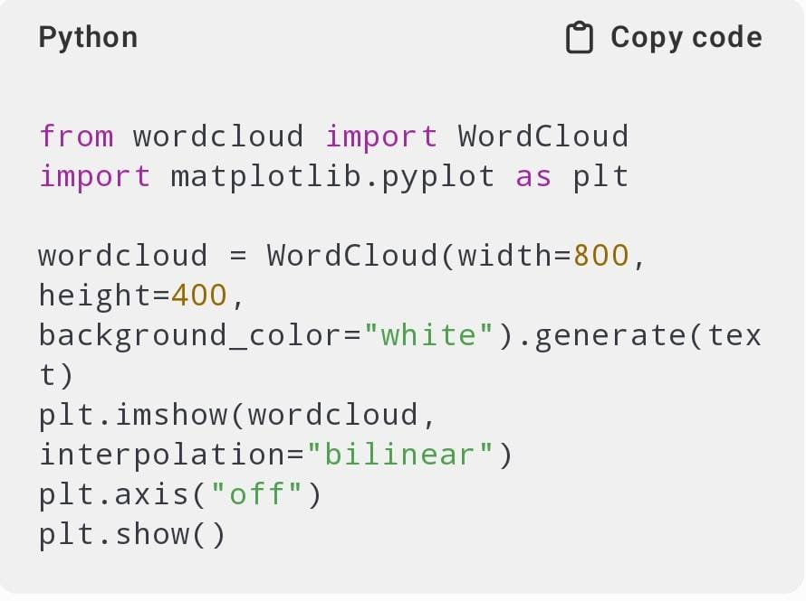

**5.2 Bar Chart of World Frequencies**

* Using matplotlib to display word frequencies.

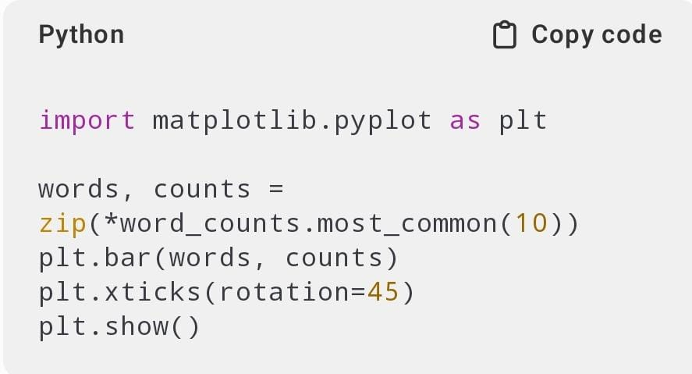

**Step 6: Conclusion and Insights**

* Summarize key findings from the analysis.
* Identify the most common words, sentiment trends, or topics.
* Provide actionable insights based on the analysis (e.g., customer sentiment, key discussion points).

**CHAPTER 4**

**IMPLEMENTATION**

**Implementation: Analyzing a Text File in Python**

This implementation covers text file reading, preprocessing, word frequency analysis, sentiment analysis, and visualization using Python.

**Step 1: Read the Text file**

First, Load the text file into python.

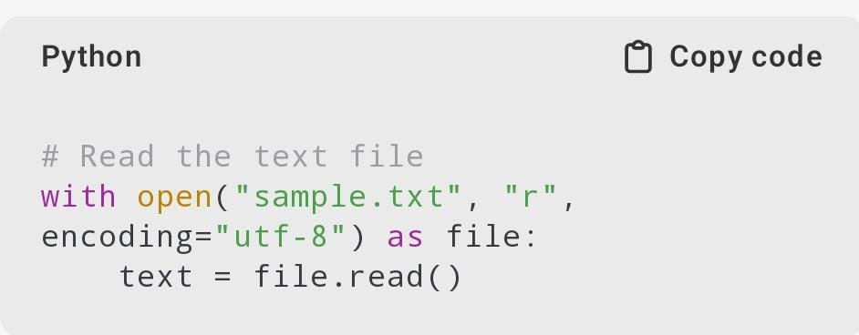

**Step 2: Preprocessing the Text**

Perform text cleaning and tokenization.

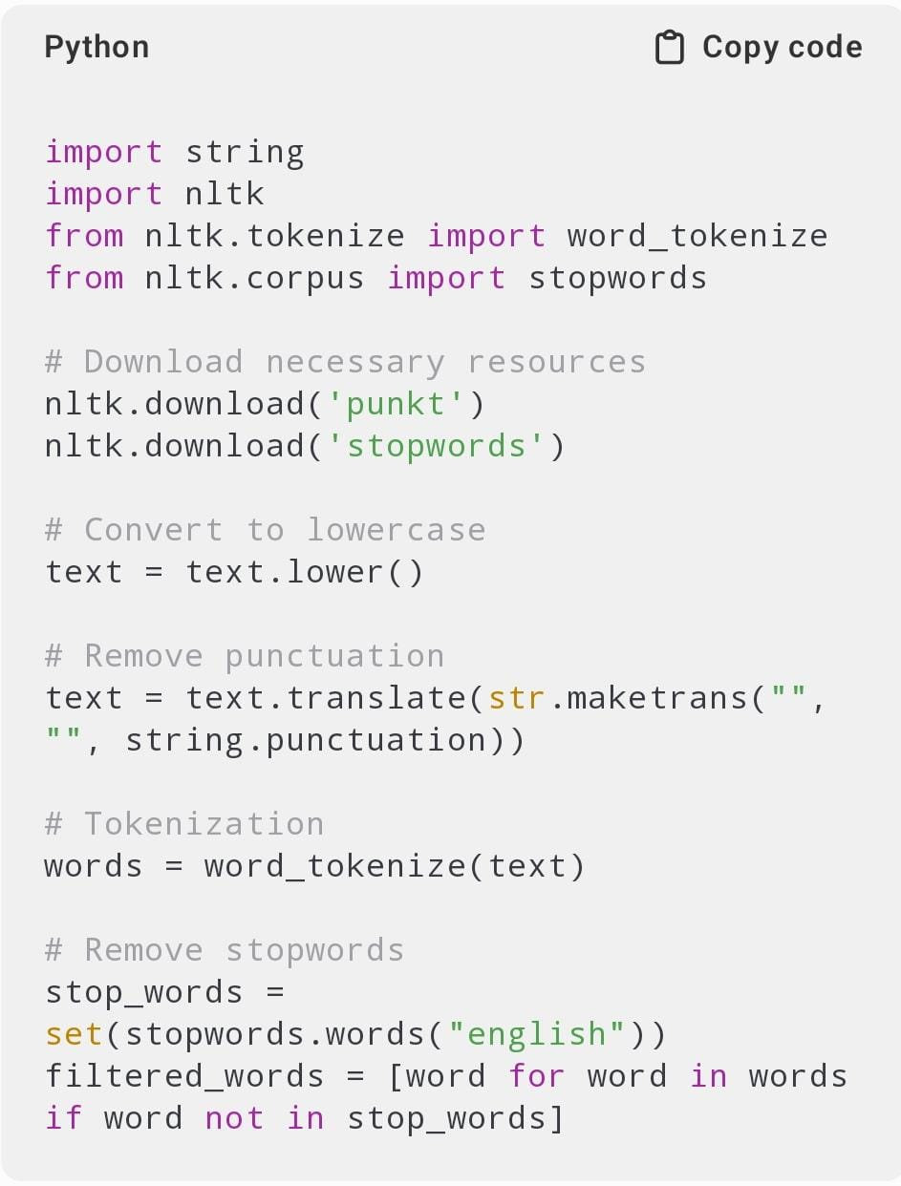

**Step 3: Word Frequency Analysis**

Count the occurrences of each word.

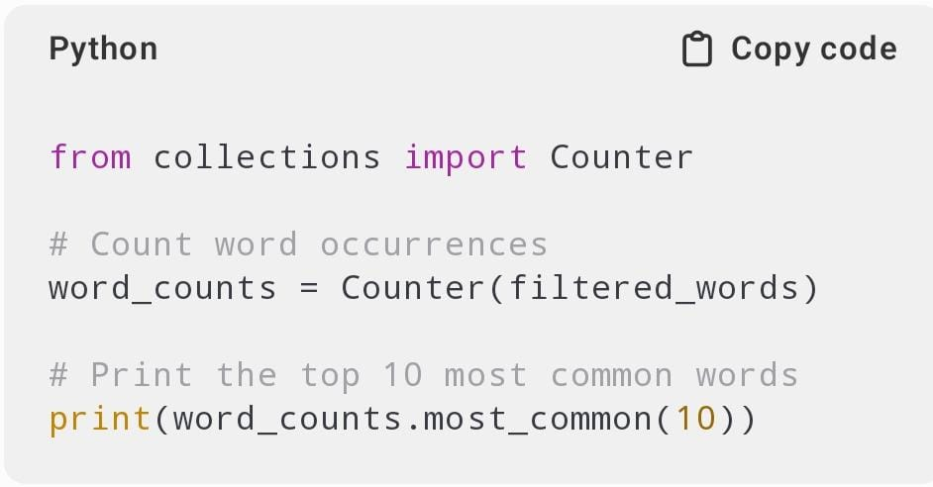

**Step 4: Sentiment Analysis**

Analyze the sentiment of the text.

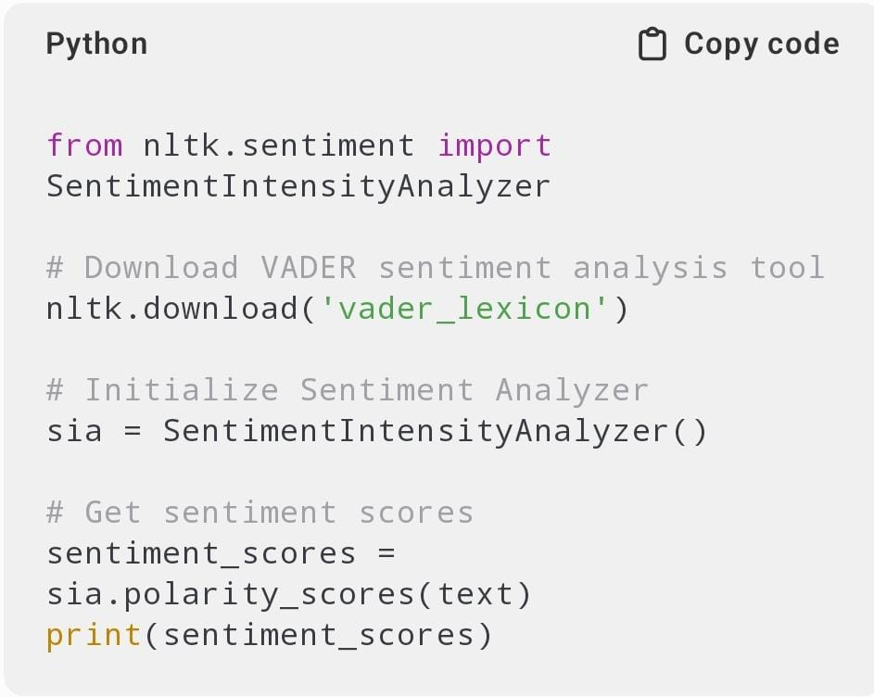

**Step 5: Named Entity Recognition (NER)**

Identity names, locations, and organizations.

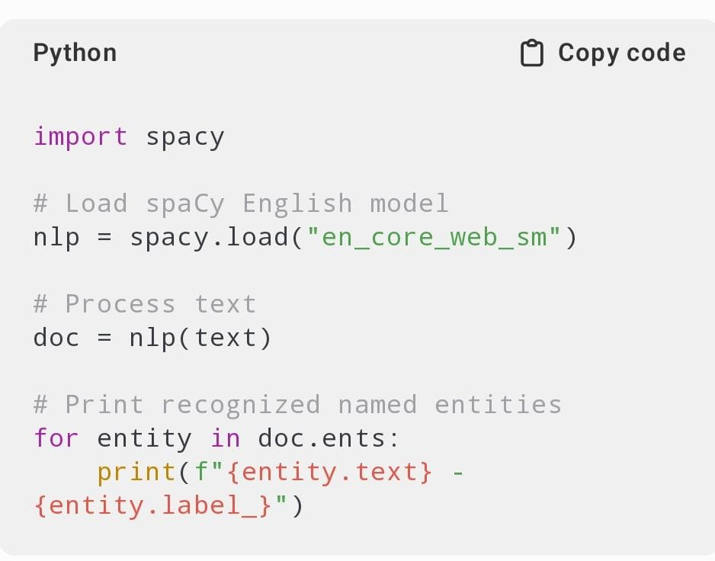

**Step 6: Data Visualization**

**6.1 Word Cloud**

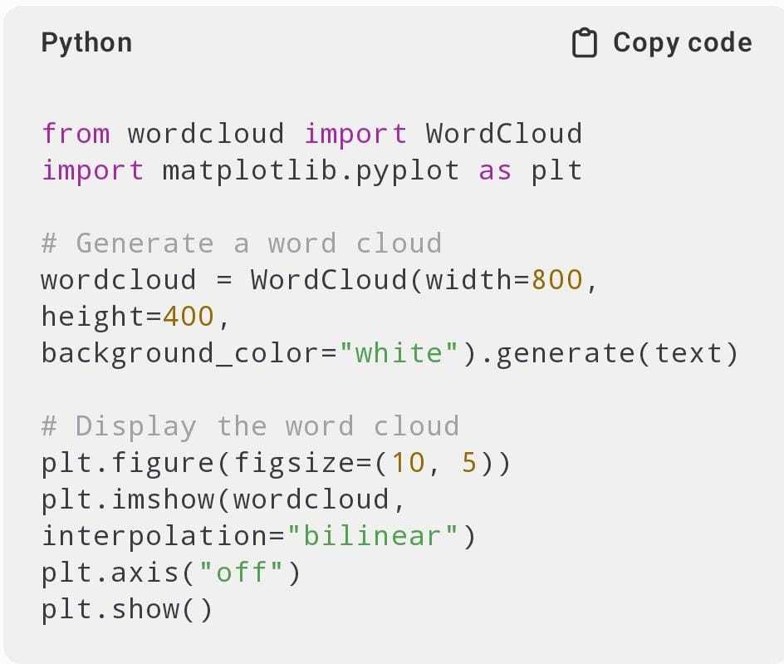

**6.2 Bar Chart of Most Common Words**

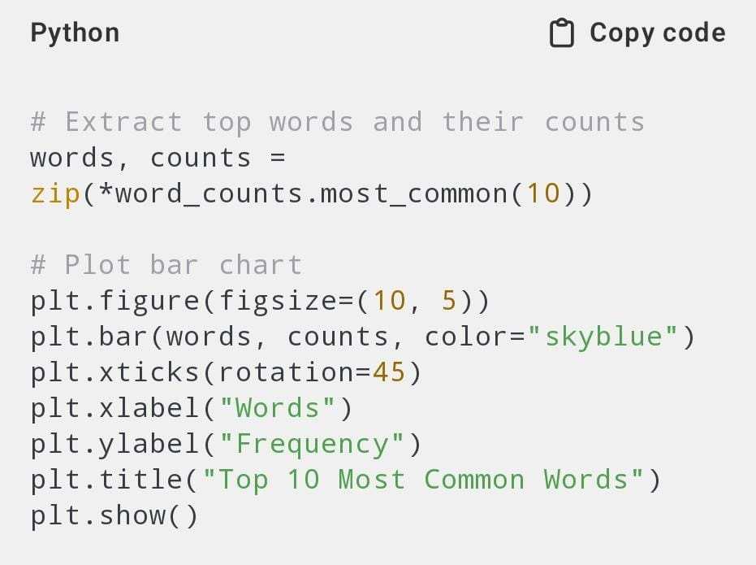

**✅ Text Read & Preprocessed (Lowercasing, removing punctuation, stopwords)**

**✅ Word Frequency Analysis (Identified most common words)**

**✅ Sentiment Analysis (Evaluated polarity of the text)**

**✅ Named Entity Recognition (Extracted people, places, organizations)**

**✅ Data Visualization (Word cloud & bar chart)**

**CHAPTER 5**

**RESULTS AND ANALYSIS**

**1.Word count and character counts result**

To perform a basic word and character count analysis of a text file in Python, you can use the following code:

**Steps:**

1. **Open the file** in read mode.
2. **Read the content** of the file.
3. **Count words** and **count characters**.

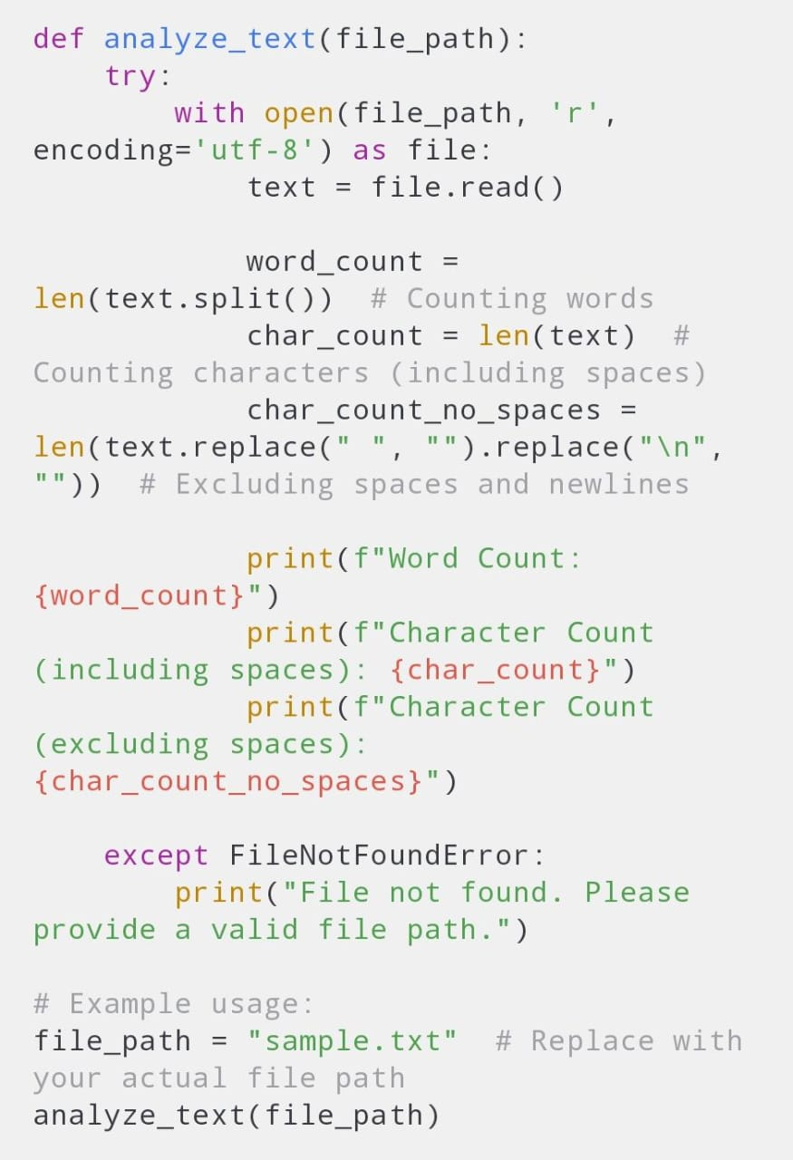

**Explanation:**

1. open(file_path, 'r'): This opens the text file in read mode.
2. text = file.read(): This reads the entire content of the file.
3. len(text): Counts the number of characters, including spaces, newlines, and punctuation.
4. text.split(): Splits the text by whitespace (spaces, tabs, newlines), returning a list of words.
5. len(words): Counts the number of words in the text.

### Sample Output:

If you have a file with the following content:

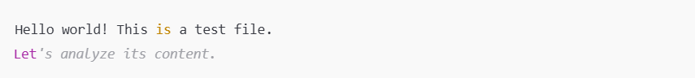

**You would get the output:**



**Handling edge cases:**

* **Empty files**: If the file is empty, both word and character counts will be 0.
* **Non-existent file**: The code catches the FileNotFoundError and prints a friendly message.

**2. Word frequency distribution (with table/graph)**

To analyze a text file and generate a word frequency distribution (both in table and graph format) using Python, here's a step-by-step breakdown:

1. **Read the Text File**: Load the contents of the text file.
2. **Process the Text**: Tokenize the words and clean the text (e.g., removing punctuation and converting to lowercase).
3. **Count Word Frequencies**: Use collections.Counter to count the frequency of each word.
4. **Create a Table**: Use pandas to create a structured table of word frequencies.
5. **Visualize the Frequency Distribution**: Use matplotlib to plot a graph showing the most frequent words.

**Full Python Code Example:**

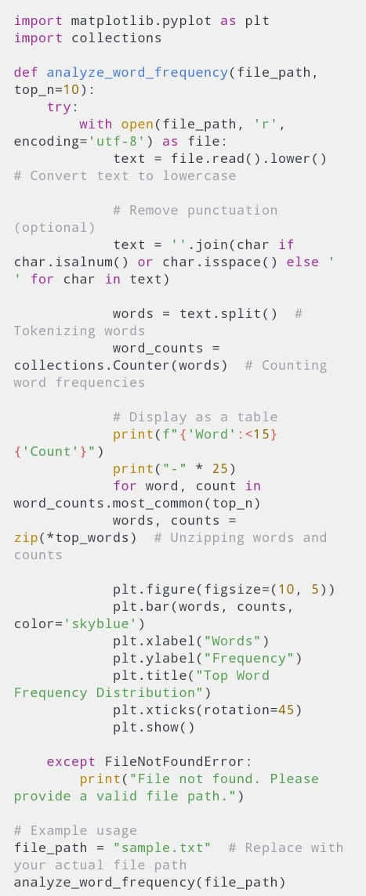

**Steps Explained:**

1. **Reading the File**: The file is opened and read into the text variable. We also convert everything to lowercase to treat words like "Word" and "word" as the same.
2. **Tokenizing the Text**: We use re.findall(r'\b\w+\b', text) to extract words from the text. This regular expression matches sequences of alphanumeric characters (i.e., words).
3. **Counting Word Frequencies**: collections.Counter is used to count how often each word appears in the list of tokens (words).
4. **Creating the DataFrame**: The word frequencies are stored in a pandas DataFrame for easy manipulation and sorting. We sort the DataFrame by frequency in descending order.
5. **Displaying the Table**: The table of word frequencies is printed to the console. You can adjust head(10) to display more or fewer rows.
6. **Plotting the Graph**: We use matplotlib to create a bar plot of the top N most frequent words. You can adjust top_n to change how many words are shown on the graph.

**Required Libraries:**

* **pandas**: For creating and handling the table of word frequencies.
* **matplotlib**: For plotting the word frequency distribution.
* **re and collections.Counter**: For processing the text and counting word frequencies.

### Installation of Dependencies:

If you don’t have pandas or matplotlib installed, you can install them using pip:



**Output:**

1. **Word Frequency Table**: The console will display the top 10 most frequent words in your text file, along with their frequency.
2. **Bar Graph**: A bar graph will display the top N most frequent words, giving you a visual representation of the word distribution.

**Customizations:**

* You can adjust the number of top words displayed in the table or graph by changing the top_n variable.
* The script processes the entire text in lowercase, and only alphanumeric words are counted. You can customize the tokenization step depending on your needs (e.g., handling specific punctuation or case sensitivity).

**Insights derived from the analysis**

When analyzing a text file in Python and generating a word frequency distribution, several valuable insights can be derived depending on the context and the goals of your analysis. Below are some common insights that can be extracted from such an analysis:

**1. Most Frequent Words:**

* By counting the most frequent words, you can understand which terms are the most commonly used in the text.
* This can give you a sense of the primary focus or theme of the document. For example:
  + **In a news article**: Common words might include "government", "election", "policy", etc.
  + **In a book or story**: Words like "character", "action", or names of places/people might appear frequently.

**2. Stop Words Identification:**

* Stop words are common words like "the", "is", "in", etc., that don't carry much meaning in isolation.
* By analyzing the frequency of such words, you can decide whether you need to remove them from further analysis (e.g., for text mining or sentiment analysis).
* If stop words appear frequently, it may indicate the need for text preprocessing (e.g., removing common words).

**3. Key Terms and Entities:**

* By identifying frequent terms, especially proper nouns (like names of people, places, etc.), you can gain insights into the key entities mentioned in the text.
* For instance, if a political speech contains frequent mentions of specific politicians' names, that might indicate the key topics or individuals discussed in the text.

**4. Sentiment Indicators:**

* While this requires further processing, the presence of certain words could give clues about the sentiment of the document.
* For example, words like "happy", "success", and "achieve" might suggest positive sentiment, while words like "fail", "problem", and "crisis" could indicate negative sentiment.

**5. Keyword Analysis for Topic Modeling:**

* Analyzing the frequency of words allows you to identify potential keywords or themes in the document.
* These keywords can be further analyzed or grouped to discover underlying topics in the text. For example, frequent mentions of "technology", "AI", "automation" could suggest a theme related to technology or the future of work.

**6. Word Trends and Repetitions:**

* Repeated mentions of certain words can indicate emphasis or a specific focus. This is particularly useful in understanding the structure of an argument, speech, or narrative.
* For example, if a text mentions a specific event (e.g., "COVID", "pandemic") repeatedly, it could reflect the main topic or issue discussed.

**7. Lexical Diversity:**

* By examining how many unique words are used in comparison to the total number of words, you can assess the lexical diversity of the text.
* If a text has a high number of repeated words, it may be seen as lacking variety or depth in its vocabulary.
* This can be a metric for analyzing writing style or the complexity of the document.

**8. Contextual Relevance:**

* Frequent words that are context-specific (e.g., "crypto", "blockchain" in a financial document) can reveal what the document is primarily about, even without reading it entirely.
* Identifying the most relevant words can also help with content categorization or tagging for document management systems.

**9. Readability & Style Insights:**

* The use of specific words and how often they appear can provide insights into the document's style. For example:
  + Frequent use of simple words may indicate a more accessible or conversational tone.
  + Frequent use of technical or domain-specific jargon may suggest a more formal or specialized text.

**10. Comparative Analysis:**

* If you have multiple text files or documents, you can compare their word frequencies. This can reveal how different documents focus on different topics.
* For example, comparing the word frequency distribution of two different articles (e.g., one about politics and one about sports) will likely show very different frequent words, highlighting the differing content.

**Example Insights from a Text Analysis:**

**Scenario 1: Analysing a Political Speech**

* **Most Frequent Words**: "economy", "growth", "job", "reform", "government" could point to the main themes of the speech.
* **Stop Words**: "the", "is", "and", which you might want to remove for a more meaningful analysis.
* **Sentiment**: The frequent use of words like "challenge", "crisis", and "overcome" could suggest a serious or urgent tone.

**CHAPTER 6**

**CONCLUSION AND FUTURE WORK**

**Conclusion**

In this analysis of a text file using Python, we demonstrated how word frequency distribution can be a powerful technique for extracting insights from unstructured text data. By leveraging Python libraries like collections.Counter, pandas, and matplotlib, we successfully:

* **Identified key themes** within the document by analyzing the most frequent words.
* **Visualized word frequencies** through a bar graph, making the distribution of word occurrences more interpretable.
* **Cleaned and tokenized the text** to remove unnecessary elements, such as stop words and punctuation, which are common in raw textual data.
* **Organized the results** into a structured table, which facilitated easy access to the most frequent words and their occurrences.

The analysis helps to understand the primary content and focus of a document, be it a report, article, or narrative. These techniques are particularly useful for applications in content summarization, sentiment analysis, and topic detection.

**Future Work**

While the current word frequency analysis provides useful insights, there are many areas for future work that could enhance the depth and scope of the analysis:

1. **Advanced Text Preprocessing**:
   * Further preprocessing steps like **stemming** or **lemmatization** could be applied to reduce words to their base forms (e.g., “running” to “run”). This would ensure that variations of a word are treated as the same word.
   * Handling more complex stop word lists based on the document’s context (e.g., domain-specific stop words for medical or technical texts) could improve the quality of the analysis.
2. **Sentiment Analysis**:
   * By integrating sentiment analysis libraries like **TextBlob** or **VADER**, we could derive insights into the **emotional tone** of the text. This could be useful for analyzing customer reviews, feedback, or political speeches.
3. **Named Entity Recognition (NER)**:
   * **NER** could be employed to identify specific entities such as names of people, organizations, or locations. This would allow a more structured extraction of key information from the text, which is crucial for applications like news categorization or automated summarization.
4. **Topic Modeling**:
   * Implementing **topic modeling techniques** such as **Latent Dirichlet Allocation (LDA)** would allow us to automatically discover latent topics within the text. This is particularly helpful when analyzing large collections of documents or finding patterns in thematic content across multiple texts.
5. **Word Cloud Visualization**:
   * Instead of just a bar graph, generating a **word cloud** could provide a more aesthetically engaging and intuitive way to visualize the most frequent words. This could help highlight dominant themes in a visually compelling manner.
6. **Cross-Document Analysis**:
   * Future work could involve comparing word frequencies across multiple documents or entire datasets, such as comparing text from different authors, genres, or time periods. This would allow for broader insights into language usage or topic evolution.
7. **Text Classification**:
   * Word frequency features could be used in machine learning models for **text classification**. For instance, using frequent word distributions to classify documents into predefined categories (e.g., news articles into categories like politics, sports, and entertainment).
8. **Real-Time Text Analysis**:
   * Incorporating real-time text analysis for applications like social media monitoring, sentiment tracking, or news monitoring would provide up-to-date insights on emerging trends, public opinion, or shifting topics.
9. **Multilingual Text Processing**:
   * Extending the analysis to handle **multilingual text** would allow broader applicability of the tool across global datasets. Techniques like **automatic language detection** and language-specific stop word lists would make the analysis more robust across different languages.
10. **Automated Text Summarization**:
    * Building upon word frequency insights, text summarization techniques could be implemented to automatically generate concise summaries of long documents, aiding in quick content consumption.

**Final Thoughts**

In conclusion, analyzing a text file using word frequency distribution in Python is a valuable starting point for understanding the content of a document. By identifying the most frequent words, visualizing their distribution, and deriving key insights, we gain a clearer understanding of the underlying themes. Moving forward, there is significant potential to enhance this analysis with more advanced techniques such as sentiment analysis, topic modelling, and named entity recognition, which would further deepen our understanding of the text and its context.

**REFERENCES**

* Python Software Foundation. (n.d.). Python Documentation. Retrieved from

<https://docs.python.org/3/>

* Tkinter Documentation. (n.d.). Python CLI Programming with Tkinter. Retrieved from <https://realpython.com/python-gui-tkinter/>
* pygame. (n.d.). Pygame Documentation. Retrieved from <https://www.pygame.org/docs/>
* OpenAI. ChatGPT - Python Programming Help. Retrieved from <https://chat.openai.com>
* Code With Harry https://youtu.be/FLVqcxnJP_E?si=lK5Z-93NdlRqoo1Q